Layouts
The Freight Express" Pack E
CityScape" Pack B
The Loop De Loop" Pack C
Industrial Town" Pack D

RealTrax Track Packs 4x8 "The Freight Express" Pack E
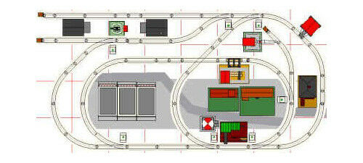
(11) MTH 40-1001 10 inch straight
(16) MTH 40-1002 O-31 curve
(2) MTH 40-1004 O31 righthand switch
(5) MTH 40-1005 O31 lefthand switch
(4) MTH 40-1018 3.5 in straight
(1) MTH 40-1012 5.5 inch half straight
(1) MTH 40-1007 45° cross
(9) MTH 40-1017 4.25 in straight
(3) MTH 40-1016 5.0 in straight
(4) MTH 40-1024 track bumper

MTH RealTrax Track Packs 4x8 "CityScape" Pack B

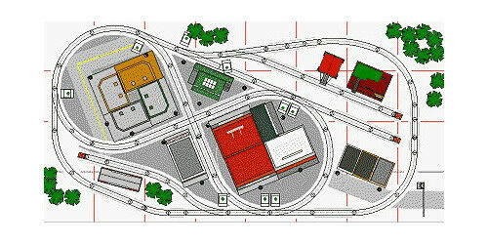
(8) MTH 40-1002 O-31 curve
(3) MTH 40-1005 O31 lefthand switch
(4) MTH 40-1004 O31 righthand switch
(12) MTH 40-1001 10 inch straight
(7) MTH 40-1022 O-31 half curve
(3) MTH 40-1017 4.25 in straight
(5) MTH 40-1018 3.5 in straight
(1) MTH 40-1006 90° cross
(1) MTH 40-1043 O42 lefthand switch
(1) MTH 40-1044 O42 righthand switch
(2) MTH 40-1016 5.0 in straight
(3) MTH 40-1024 track bumper
(2) MTH 40-1045 O42 half curve
(1) MTH 40-1054 O54 curve
(1) MTH 40-1012 5.5 inch half straight

MTH RealTrax Track Packs 4x8 "The Loop De Loop" Pack C

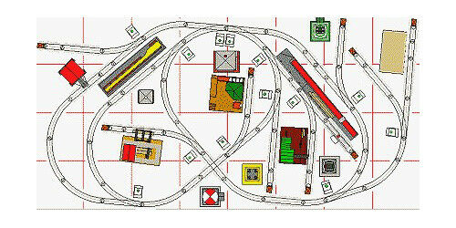
(11) MTH 40-1001 10 inch straight
(12) MTH 40-1002 O-31 curve
(6) MTH 40-1005 O31 lefthand switch
(1) MTH 40-1006 90° cross
(1) MTH 40-1012 5.5 inch half straight
(6) MTH 40-1017 4.25 in straight
(7) MTH 40-1004 O31 righthand switch
(9) MTH 40-1024 track bumper
(6) MTH 40-1018 3.5 in straight
(1) MTH 40-1008 uncoupling track
(3) MTH 40-1022 O-31 half curve

MTH RealTrax Track Packs 4x8 "Industrial Town" Pack D
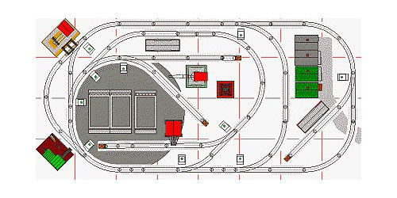

(16) MTH 40-1001 10 inch straight
(14) MTH 40-1002 O-31 curve
(5) MTH 40-1017 4.25 in straight
(7) MTH 40-1004 O31 righthand switch
(3) MTH 40-1005 O31 lefthand switch
(2) MTH 40-1012 5.5 inch half straight
(6) MTH 40-1018 3.5 in straight
(4) MTH 40-1024 track bumper
(1) MTH 40-1016 5.0 in straight

MTH RealTrax Track Packs 4x8 "Industrial City" Pack A
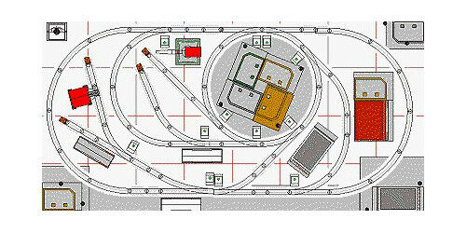
(12) MTH 40-1042 O42 curve
(7) MTH 40-1002 O-31 curve
(4) MTH 40-1005 O31 lefthand switch
(3) MTH 40-1001 10 inch straight
(6) MTH 40-1017 4.25 in straight
(7) MTH 40-1004 O31 righthand switch
(8) MTH 40-1018 3.5 in straight
(4) MTH 40-1024 track bumper
(1) MTH 40-1022 O-31 half curve
(3) MTH 40-1012 5.5 inch half straight
(1) MTH 40-1056 O54 righthand turnout
(2) MTH 40-1016 5.0 in straight

